**Kerala Crafts Update Spring 2023**



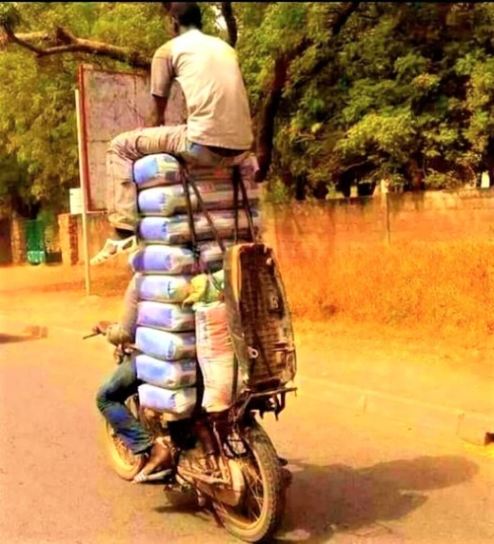 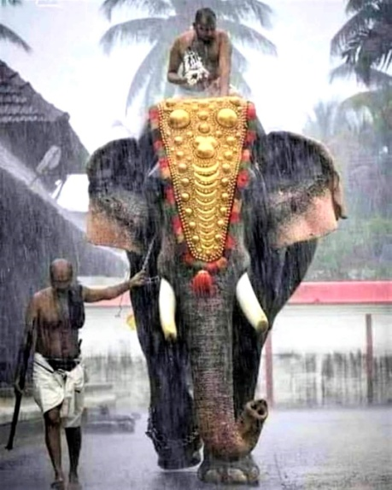 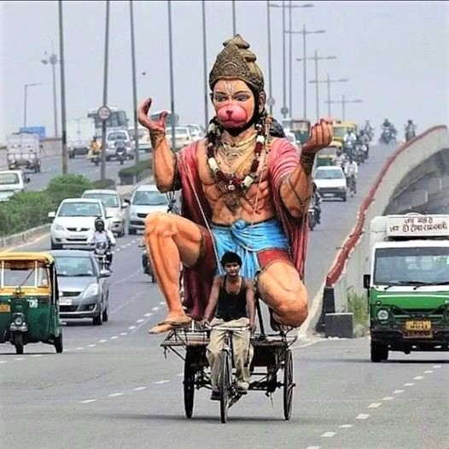

The Indian economy is expected to grow 6.9 % in the 2023 fiscal year, the World Bank has forecast, making it the world’s fastest-growing major economy. But despite economic growth, India still has one of the highest levels of income inequality in the world. The economic slowdown triggered by Covid has left a trail of misery and suffering especially on poor and vulnerable households, whose suffering still continues.

For the ordinary man in the street, it is currently a struggle to cope with the demands of life, but for the poor, they feel that there is no way out. Kerala is no exception, and in a State whose top revenue earning sector is tourism, this has been destabilising and has had a shattering effect on those already struggling to survive on a daily basis.

Our friends in Kerala say that although tourists are slowly trickling back, it hasn’t reached anywhere near how things used to be. Many consecutive seasons have been lost, and it will take a long time to recover.

Kerala Crafts has continued supporting the community projects in which we’ve been involved for some time, and with ‘friends on the ground’ we hear first-hand reports of how Covid has affected the livelihoods of so many people. We continue to do what we can to try and support the most vulnerable in society, working alongside partners in Kerala.

**Vimala Welfare Centre**

Life at Vimalalayam has mostly returned to normal, though the last year has not been without its casualties. The fibre handicraft workforce has become much diminished as workers became ill, retired or passed away. The elderly Sisters living in the complex have become very frail, and are unable to go out. The toll that Covid has taken on many, has left things very different to how they were before.

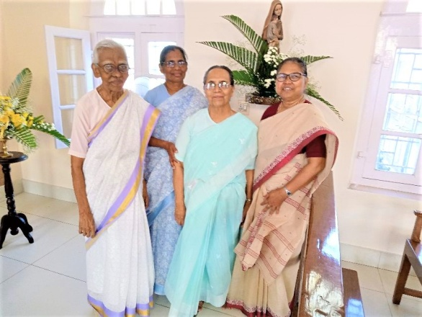 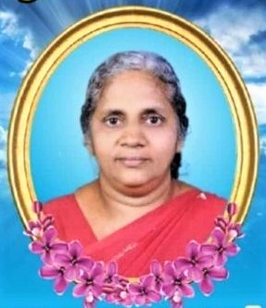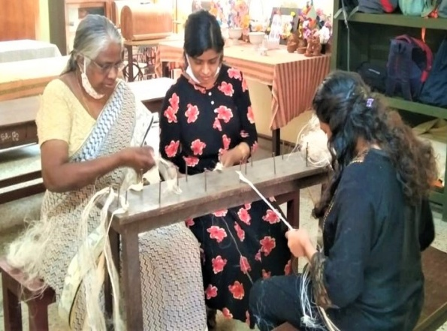

*Sr. Rita (left RIP), with Srs at Vimalalayam Pushpa (RIP) Experience and youth*

1

Out of all the retired Sisters living at Vimalalayam, five are 80+. Though not bed ridden, most have joint pain and walk with a stick. Pushpa, who dyed the fibres for the handicrafts, had a massive heart attack and died on 4th September 2022. Molly, from the same department, was in ICU, but thankfully is now well. Sr. Rita Kitho, passed away on 24th February 2023 after a stroke. Sr. Rita had been at Vimalalalyam for as long as I can remember. She passed peacefully away, aged 83, surrounded by her nieces and nephews and her fellow DHM (Daughters of the Heart of Mary) Sisters. Throughout her life she had served in missions in France and India, as a teacher, leader and social worker. Her gentleness and her availability to others, especially encouraging and nurturing the younger girls, will be sorely missed.

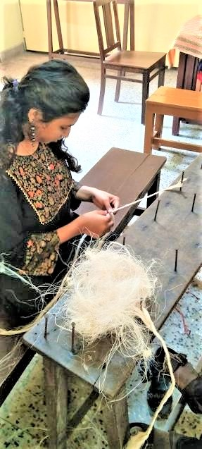 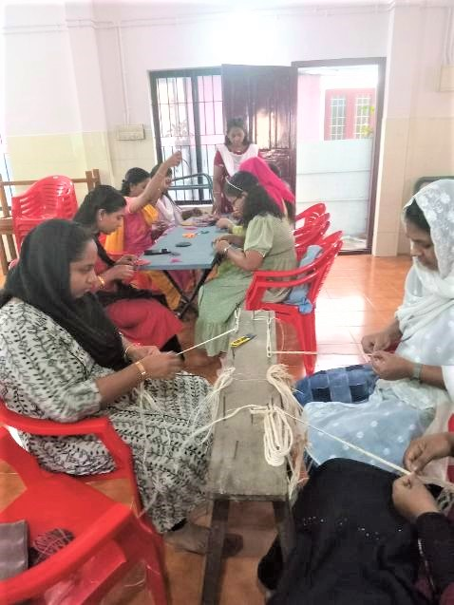 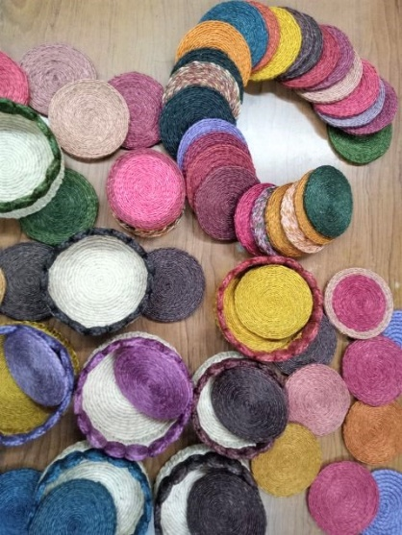

Though there is a scarcity of raw materials, and not a huge demand for goods, Sr. Sophy has created a new group of 27 women who are enthusiastic to train in making fibre articles. This is good news, as the experience of the older artisans can be passed on to the younger generation. It also preserves ancient traditions and skills that might otherwise decline, and will eventually provide much needed income for women of all ages, castes and religions – the hallmark of Vimalalayam; it is a very inclusive environment. The handicraft section continues to be an eco-friendly project as the local, natural and biodegradable banana fibre is utilised and recycled, making it a sustainable business.

**Pallavom**

Pallavom (tender shoots) project initiated by Vimalalayam Sisters, continues to nurture these disadvantaged young ladies. They have embraced the various practical courses at the Centre, and are starting to thrive.

The Sisters are adding to the girls’ experiences by taking them on beach outings, picnics etc, which they have really enjoyed as a group.

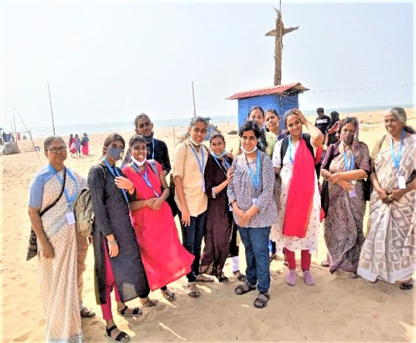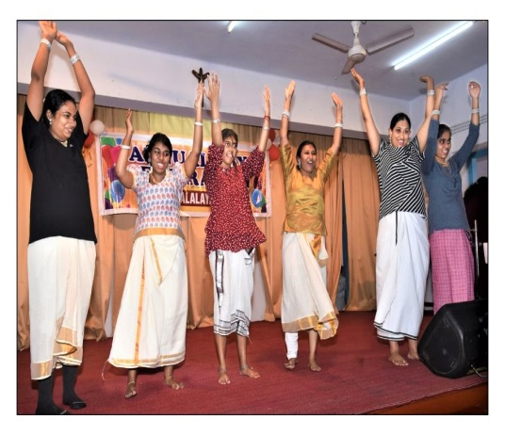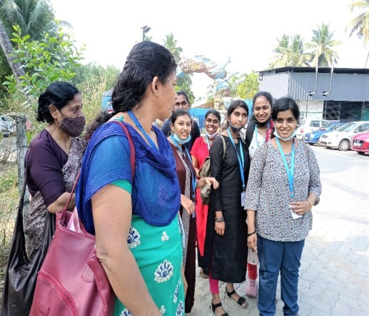

*Beach picnic Performing at Annual Day Day trip*

In February, Vimala Welfare Centre celebrated its Annual Day with special events throughout the day. This included performances by the Pallavom girls who did so well, and their parents were very encouraged by the positive changes they saw in the girls since coming to the Vimala Welfare Centre.

2

**Moolampilly**

This isolated island is supported by staff from the Vimala Welfare Centre, particularly around helping to find livelihoods for some of the islanders.

The new building, which opened in June last year, has not as yet been able to provide the planned pre-school facility for locals, as a smart anganwadi (pre-school) was opened in the same vicinity just at the same time. It is hoped that the pre-school will be able to open next academic term.

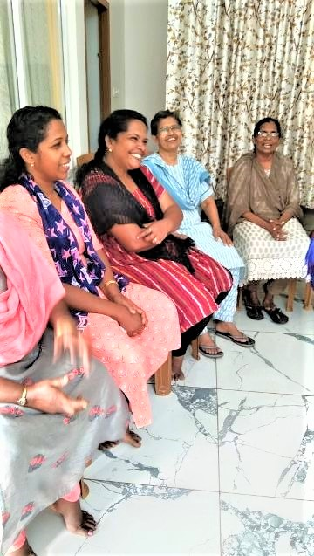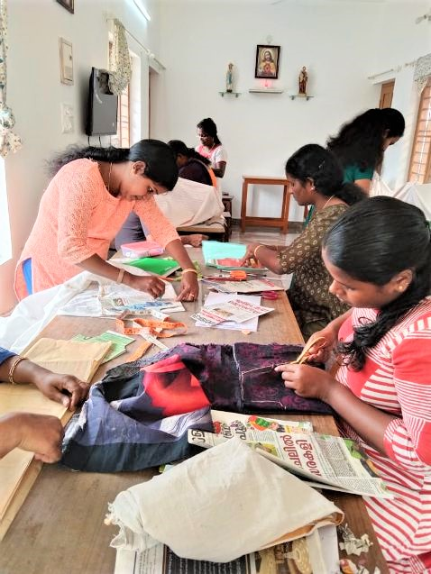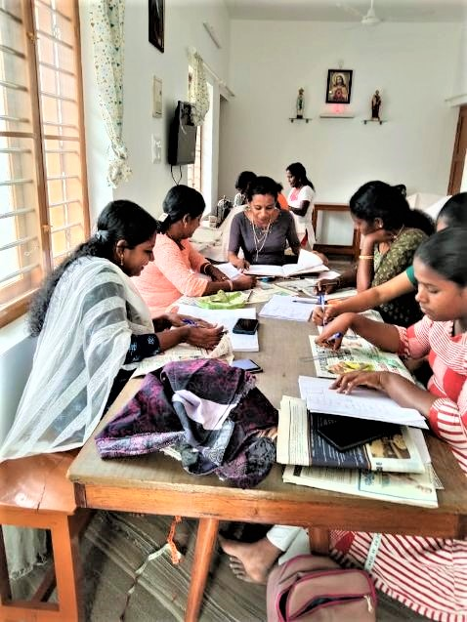

However, last December a skill training programme saw 22 women enrolling in a dress making course there, making use of the twenty sewing machines acquired. The multi-purpose hall is being utilised with these kinds of programmes as planned, and provides a meeting place, particularly for senior citizens as well as for personal counselling and preparation for marriageable girls. The area in between the new building and the existing one, is being utilised for fish cultivation and organic farming.

On 23rd December 2022, there was a Christmas get-together for everyone in the Vimalalayam family with special treats for all. Funds from Kerala Crafts were given specifically for this purpose.

**Valsalya Bhavan**

Currently, all children are back at school full time, and enjoying some special events in which many of our girls participated.

In June the girls enjoyed a trip to Thrissur to the State Museum, Zoo and Nehru Park. They also had a day filled with excitement at the Wonderla water theme park. They loved the thrill of the roller coaster rides and water slides. Tired and happy, they took home some great memories. This outing was kindly provided by the generosity of a well-wisher. If you might be interested in providing the children with an unforgettable experience, a Christmas meal or something to bring a smile to their faces, please get in touch.

[christine.snow@blueyonder.co.uk](mailto:christine.snow@blueyonder.co.uk)

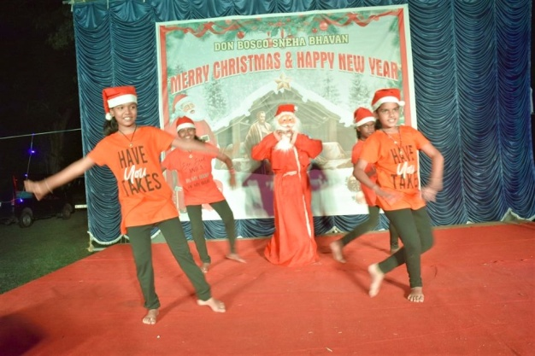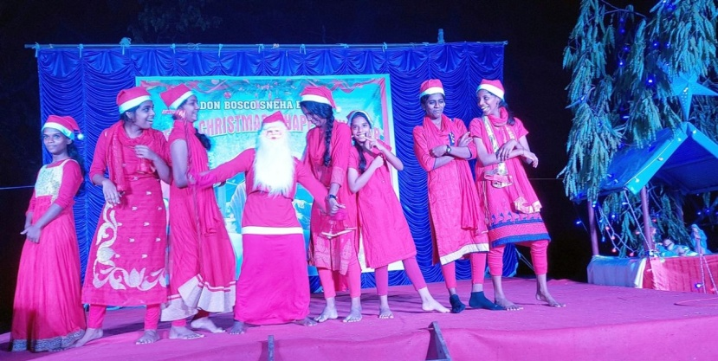

3

Another memorable day for the girls was a day at the Holiday Inn, when the girls were invited to demonstrate their skills in craft work and to showcase their talents in singing, painting and dancing. All the children were happy and took part with great enthusiasm. They enjoyed the day very much and had exposure to the functioning of a large hotel.

The children also enjoyed the Summer Camp (Venalkoottu) with group activities, games and sessions set up specially for them. There were multiple casework sessions as well as dance and singing activities that the children cheerfully took part in. The girls will carry with them fond memories and invaluable knowledge which will stay with them for ever. Valsalya Bhavan commenced their new academic year with a session of yoga where the girls synchronised their yoga postures following the directions of the yoga instructor. This session will instil a sense of discipline physically, mentally and spiritually. Their physical fitness levels and stress relief were enhanced through the various relaxation techniques practised.

Seven girls from Valsalya Bhavan Annex have completed their 10th grade, and are going into further education, having gained admission to St Mary’s, St Theresa’s and Sreenarayana Higher Secondary School for their Plus 2 studies.

Class 12 results were declared on 21st June 2022. To commemorate the success of the students, the girls were adorned with ponnada (beautiful shawl given as a sign of respect) and gifts. Two of the girls, who had passed their 12th grade exams with flying colours, were also given gifts by Sr. Shirly

Furthermore, Gouri has passed her Plus 2 Science with 73% and has been admitted to Colombia College in Bangalore to pursue her B.Sc. Nursing Studies.

Anagha Subhash has completed her MLT course and is pursuing her higher studies in nursing at Mangalore, Karnataka.

Chinchu Suresh has completed her secondary education and has decided to learn German, and wishes to study in Germany. The girls should rightly be proud of their achievements, and we wish them all the best in their journey forwards towards obtaining degrees and a career to sustain themselves.

The girls going into higher studies have hostel facilities arranged for them within the colleges where they are studying and those who are working have lodgings arranged for them next to their workplace.

Maheswari, a student once at Adelaide Bhavan, was married in the summer of 2022 and now lives with her in-laws in Piravam. We sent money as a wedding gift, and wish her well in her new life.

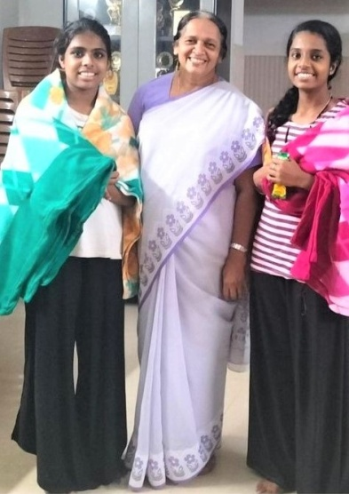 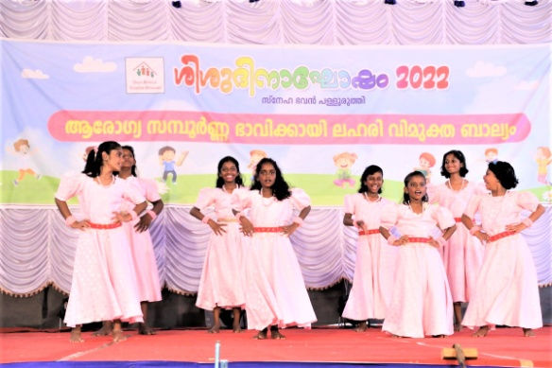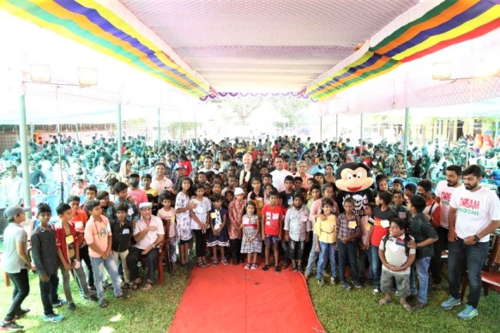

*Sr Shirly, Chinchu & Anagha Girls performing on stage Hundreds gathered for Children’s Day*

On 13th November ’22, Children’s Day was celebrated, with over 1,000 children gathering for the celebration. This is the biggest event that all the children look forward to at Don Bosco homes and the local neighbourhood. After a long two year break due to covid restrictions, this event saw a stage full of esteemed guests, tasty food, games, fun and frolics, cultural events, anti-drug art exhibition, gifts for all and a whole day of enjoyment. What a day to remember!

Girls from Valsalya Bhavan annex were also given the opportunity to showcase a phenomenal performance of classical dance at the nearby Vaduthala temple on Vidyarambham Day (Hindu initiation ceremony that is performed before children start their formal education – a popular event in south India). This was under the guidance of Sr Shirly.

4

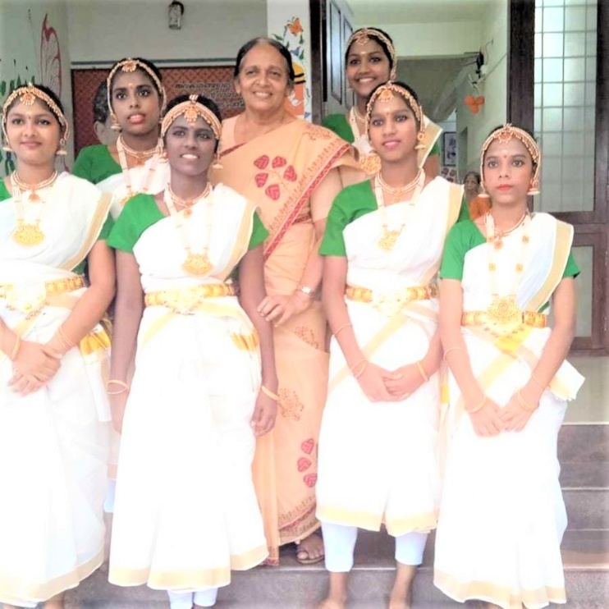 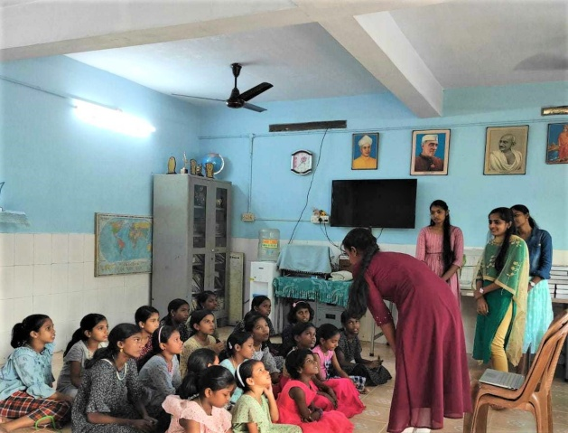

**Back:** Chinchu, Sr Shirly, Krishna **Front:** Thrishna, Vineetha, Shincy, Sajana *Good touch/bad touch community programme*

At Christmas, all the girls received a card from us, and sponsors in return received a Christmas card with beautiful artwork . We sent money so that all the children could have extra treats too.

The girls are so appreciative of the letters and cards they receive from their sponsors, and often add heartrenching messages to their ‘aunty & uncle’.

**‘Your love and care is the visible heaven in our earth. And both of you are the cute angels in my heaven’.**

**‘Thank you for your unlimited love and care’.**

**‘I always thank God for keeping my soul in safe hands’.**

In January this year, the younger girls hosted a community programme about ‘good touch/bad touch’. A group of social workers from Marian College and St Thomas College coordinated the programme. The main motive was to provide children with more knowledge and training to protect themselves from sexual abuse. They were encouraged in the need for open communication between parents and their children, friends and relatives. In order to make the sessions more clear, the programme included multiple communication techniques such as ice breaking sessions, awareness sessions, video presentations and role play. The Valsalya Bhavan Ammathottil girls found the class to be very enlightening.

February 2023 saw the Silver Jubilee of Valsalya Bhavan being celebrated. In 1997 a home for exploited and abandoned girls was set up in Kochi (Cochin) by the civic body and Don Bosco Sneha Bhavan with support from the Overseas Development Authority. A study had found that the major cause for the spread of AIDS in the city was sex workers, who had made Kochi their base.

The girls needed to be rehabilitated to prevent them from becoming sex workers themselves, which would be a major step towards containing the spread of the disease. The girls rescued were not only children of sex workers, but also those abandoned on the streets, girls of HIV positive parents, run aways and rescued girls from bonded labour and other similar situations.

Valsalya Bhavan was set up in a room on Old Railway Station Road in June 1997. More than half of the girls at VB now do not have a family and most are malnourished when they arrive.

“I have no remembrance of my home, my parents .... I was on the streets from my earliest memory. We were a group of children that lived around the Marine Drive .... picking, begging ..... I don’t know how I reached the streets. Maybe I didn’t have to reach ... I was already there from my beginning .... may be.

5

One day we were all rounded up by the police. ‘Beggary is prohibited. You have no more right to be on the streets, because you are beggars they told us. In the police van we were transported to the Relief Settlement of Corporation and locked up. Men and women, sane and insane, children and aged ..... A big number of so-called ‘social rejects’ just survived there ..... and life there, was difficult ....... very difficult. Then staff from Don Bosco visited us bringing a cinema projector and showed us films. They spent time talking to us. Their visit was a ray of hope in the otherwise drab lives we lived there. They told us about how they and the City Corporation wanted to take us away and educate us. We waited in eager expectation”.

Over the last 25 years, the centre has provided shelter, education, holistic growth and rehabilitation to more than 3,000 orphaned, destitute and abandoned girls. Now Valsalya Bhavan has two centres:

Valsalya Bhavan, Ammathottil at Ponnurunny for girls below the age of 12 and Valsalya Bhavan Annex at Vaduthala for girls aged 13 – 19 and those in higher education.

Today the major work involves children being referred to Valsalya Bhavan by the District Child Line and District Child Welfare Committee.

The children at Valsalya Bhavan are given training in various vocational fields like computers and tailoring along with their regular studies. They also have athletic training programmes like judo, music and various dance forms especially Zumba and classical dance to help make them self-reliant and to gain them a secure place in society. Programmes like Kalari training are added to boost their courage and confidence in life. Everything they learn here will be useful in life – everything they need for family life in the future.

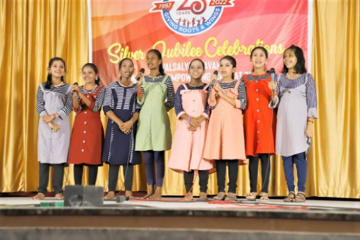 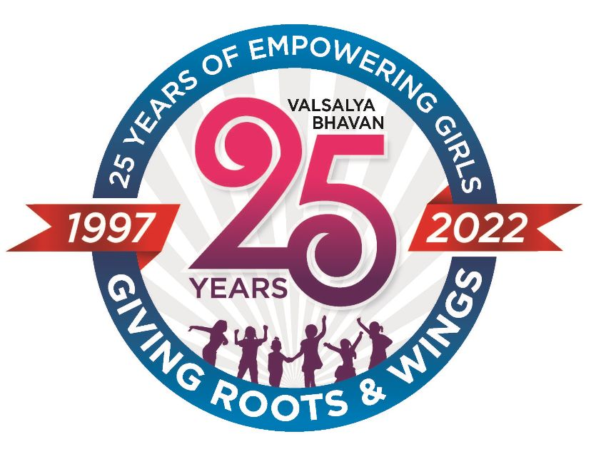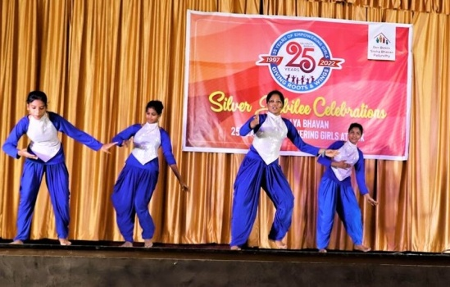

The Silver Jubilee celebration of Valsalya Bhavan was held at the Don Bosco auditorium, Vaduthala (next door to the girls’ orphanage). It was attended by several dignatories, and welcomed by Fr P.D. Thomas, along with Sr Reeta DHM and Sisters from Vimalalayam. A cultural extravaganza followed after the public meeting in which children from all the Don Bosco children’s centres (past and present pupils) put on a special performance.

The Vimalalayam Sisters have played a big role in ensuring the welfare of girls at Valsalya Bhavan.

If you would like to sponsor a child, please follow the link or email.

<http://www.keralacrafts.co.uk/sponsorship.html>

**She’s**

Things at She’s have ticked over quietly during the last few months. Sadly, we have been unable to continue giving orders to Shyni and her team for PJ’s and undies, as sales in the U.K. have been almost non-existent for months now. Please see later article about this in the newsletter.

Due to less work, some ladies have had to cease working at the shop and things are a struggle at present. The economic situation is bad in India as well as here, and although local work is busier around festival times, steady work is not there.

Shyni’s son, Kannan, is now in the second year of his B.Sc Medical Imaging Technology degree at SRM Medical College in Chennai. Kerala Crafts is providing funds for his college fees and lodging. He is doing well, achieving decent marks and has good attendance at college. He likes his course and has made many friends and has become a smart and independent adult.

When he qualifies, his future will be bright for himself and his mother.

**6**

**Sara Antony**

Sara is a young lady who became known to us through Fr. Merton at Kadamakudy. Sara was a student at Wright International Aviation Management, Thevara, Ernakulum. Her father is a mason and her mother is a housewife, and she has 2 brothers. Since the pandemic her father has had no work and was therefore unable to finish paying her college fees. To work as cabin crew is her deepest desire. Her college placed all students into interviews, but not Sara as she had been unable to pay her fees. Kerala Crafts stepped in and paid the balance owing, so that she could follow her dream, and also helped to fund a mobile phone which was vital for her studies etc.

Sara recently had an interview with IndiGo airlines in Kochi, and has been shortlisted. We hope soon, that she will be able to do the job she really wants and needs, as there is no other income coming into her home.

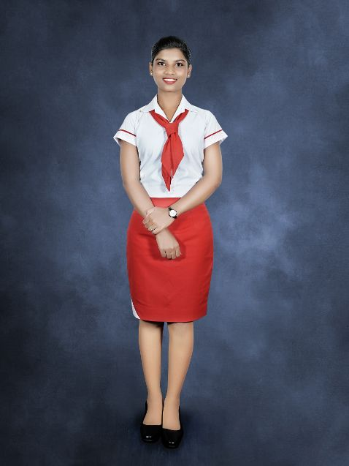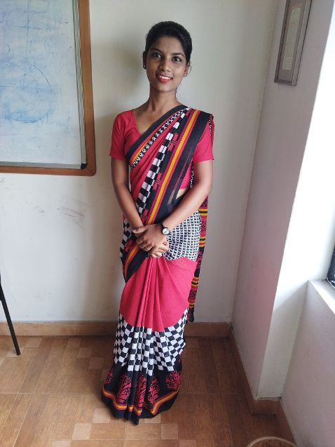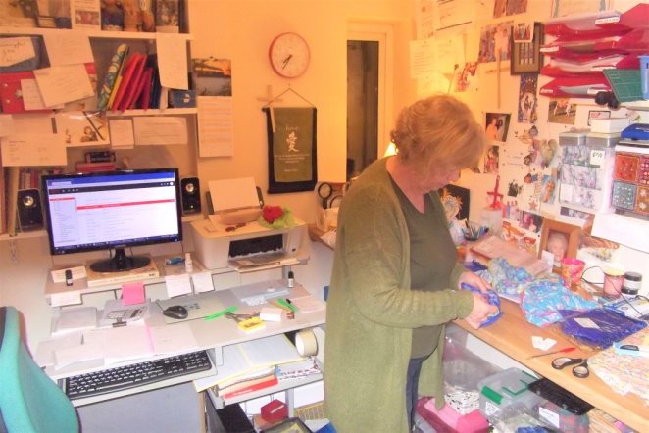

Sara in her airline uniform At home Christine in her little study sending off undies

**IMPORTANT ANNOUNCEMENT FROM KERALA CRAFTS**

After much deliberating and soul searching, and with the trustees in agreement, it has been decided that the time has come for the sales side of Kerala Crafts to cease trading.

It was difficult, but the decision was really made for us. Sales have been consistently poor for the last year, due in part to being unable to receive goods from Kerala during lockdown, and sadly things don’t look set to improve long term. In addition, the UK economy has taken a nose dive and UK prices have sky rocketed. As most of our online sales are to UK customers, our sales have virtually collapsed. Therefore little income has been generated for our vital projects.

So given this and reaching the age of 70, it seems that now is the right time to close down this part of the charity. We have had some good sales over the years, and many loyal customers who have repeatedly bought our products. As much as we had hoped to keep the skilled ladies, led by Shyni, in Kerala in work, this has become unsustainable. There is little point in giving them more orders if we can’t sell their products here.

Of course, the sponsorship scheme for the orphanage girls will remain in place and we will endeavour to continue to support our other community projects as long as funds last.

A big ‘thank you’ goes to all our loyal customers – their purchases of ‘smalls’ has made a ‘big’ difference to Shyni and her team of workers. So many people to thank! We really want to continue the work we started but we will now have to rely solely on donations to be able to do this. The Meaningful Gifts page will still be on the website, whilst there are still a few reduced items remaining for sale as stock runs down. So grab a bargain while you can!

**Bespoke undies for just £4 or £5, and boxer shorts for £5, plus half-price essential oils.**

<http://www.keralacrafts.co.uk/meaningful-gifts.html> <http://www.keralacrafts.co.uk/new-essential-oils.html>

<http://www.keralacrafts.co.uk/fair-trade-knickers.html> <http://www.keralacrafts.co.uk/fair-trade-mens-boxers.html>

7

I intend to visit Kerala next winter and will send out another update after that trip.

Many thanks once again for all the support that Kerala Crafts has received over the last 21 years, and continues to receive. We’ve had some lovely feedback from satisfied customers, and we have been happy and proud to provide many customers with a unique pair of knickers or boxer shorts, as well as to fly the fair trade flag!

Kindly check the website to keep updated as this is not the end of Kerala Crafts, just a new and different phase.

And finally, we have been very happy to welcome Mrs Anu Puthukudy onto our board of trustees. Anu has been invaluable in being the link between Kerala and UK, ensuring smooth communications and carrying out necessary functions in Kerala on our behalf.

Just 3 of some of the girls needing sponsorship

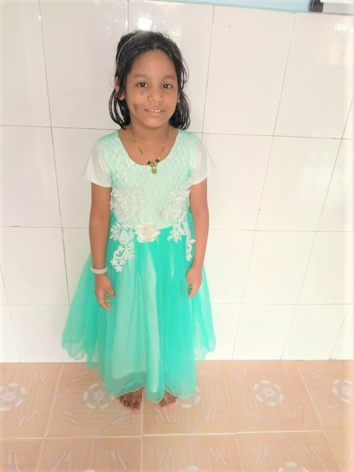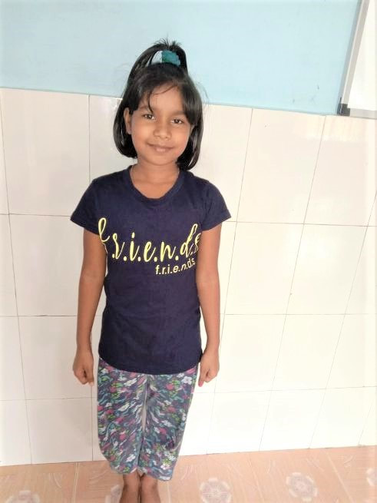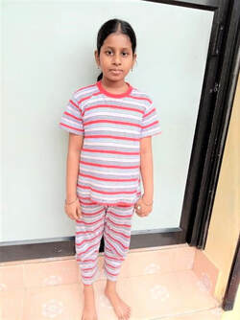

*Nandhana dob 05/06/12 Kareena dob 06/02/11 Liya dob 20/01/12*

If you would like to make a donation, our bank details are:

Sort code 20-05-12

Account number 40787159 (quoting your name in reference) Thank you



[www.keralacrafts.co.uk](http://www.keralacrafts.co.uk)

UK registered number 1138414

8