

Please complete this form if you are a UK tax payer and you want ***Kerala Crafts*** to reclaim the tax you have paid. By completing this form we can add 25% to your gift with no extra cost to you.

---------------------------------------------------------------------------------------------------------------------------------

(Title and full name)

of

(address)

------------------------------------------------------------------------------------------- Postcode ----------------------------

requests ***Kerala Crafts*** to treat all donations I have made in the last 4 years and all donations I make hereafter as Gift Aid donations.

(Signature & date signed)

Please note: to qualify for Gift Aid you must be a UK taxpayer paying an amount of income tax or capital gains tax equal to the tax we reclaim on your donations (currently 25p for every £1 you give).

Remember to inform us if you cease to pay sufficient tax.

Data Protection: all information is stored securely and never shared.

[www.keralacrafts.co.uk](http://www.keralacrafts.co.uk)

Tel: +44 (0) 1225 319642

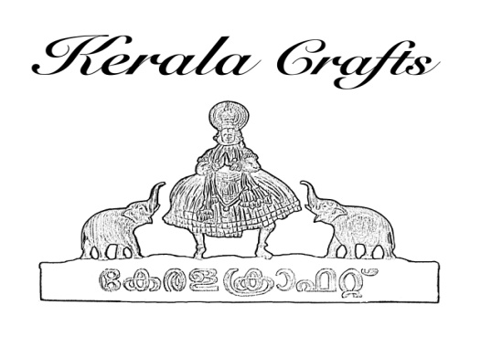

Registered Charity No: 1138414

Please send this completed form to 5 Ivy Place, Bath BA2 1AR or

email it to : [christine.snow@blueyonder.co.uk](mailto:christine.snow@blueyonder.co.uk)

Many thanks