Kerala Crafts Update- Summer 2022



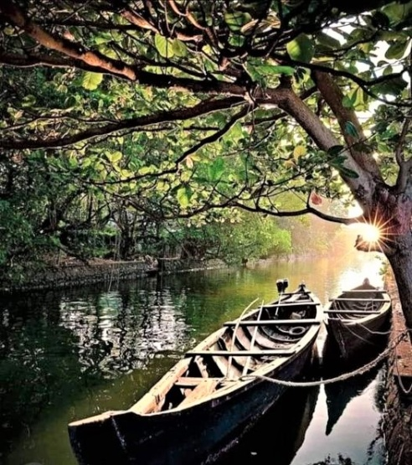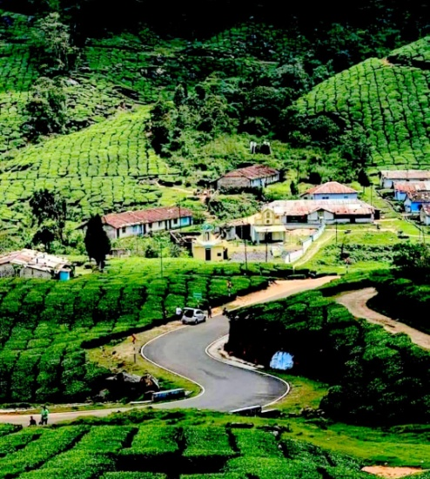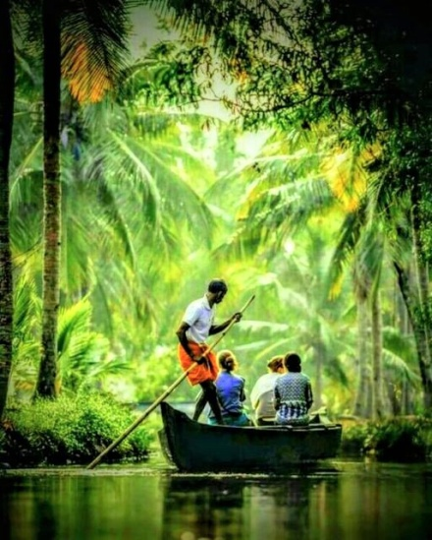

In spite of not being able to visit Kerala since 2019, a lot of things have been accomplished within the projects that Kerala Crafts supports.

Kochi (Cochin) is one of south India’s busiest cities with 600,000 people calling it home. The city is spread across a series of peninsulas and islands, connected by a network of water taxis and bridges. The projects we support are all in this area of Kerala, with a couple of other projects slightly further afield, and in every case we have long-standing connections with the people concerned.

At the end of August 2021, cases of Covid in the state were high compared to other parts of the country with nearly 20,000 cases being reported daily. Only 50% of people at this time were vaccinated. Though Kerala had the highest number of infections in India, the mortality rate was low.

In October 2021 Kerala was hit by floods again (last time was in August 2018). Although they were not severe in Ernakulam, Kottayam and Idukki districts were badly hit resulting in 28 deaths with many houses destroyed. In January 2022, the third wave of Covid was reported as spreading fast, with most households experiencing some level of sickness.

**Vimala Welfare Centre**

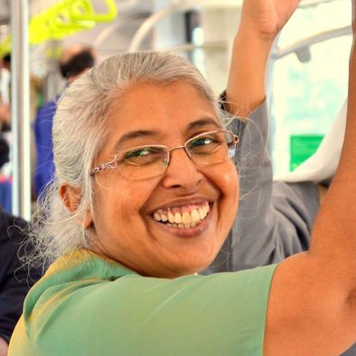 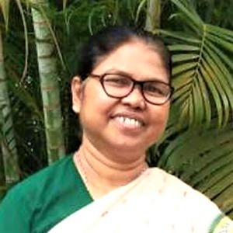 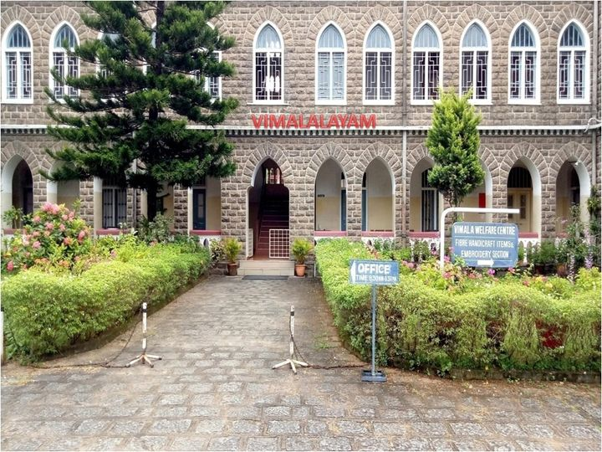

*Sr*. *Mercy -* *Principal of Vimala College*  *Sr. Sophy - Superior of Vimalalayam* *Vimalalayam*

Covid has had a big impact on the Centre, and by August 2021 few women had returned to the Centre to work, as they were fearful of catching Covid on public transport. Many of the hostel girls at Vimalalayam were infected as well as some of the staff and Sisters. The impact of Covid meant that by the end of the year, the workshop and other projects run by the Sisters were still not fully operational. But in November 2021, many of the students had returned back to the college and by March ’22, most of them had fully returned.

**Adelaide Bhavan** – numbers had dwindled to just 2 – with Vennila returning to her mother’s home in Hyderabad and Maheswari joining the older girls at Valsalya Bhavan annex. Both girls passed their Plus Two exams with good grades.

With the rooms at AB becoming vacant, they have been utilised by a new initiative set up called **Pallavom.** This means ‘tender shoots’– something that needs nourishing and care. It had been started at the beginning of 2021, but due to the pandemic, had to be put on hold. However, in September 2021, the workshop for differently-abled young and older ladies recommenced, with some of the young ladies living-in.

*1*

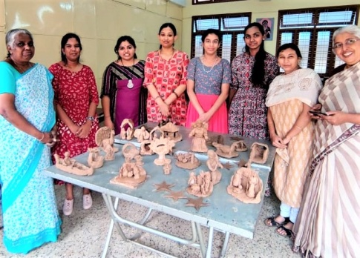 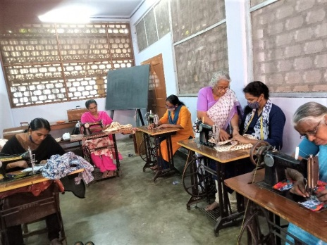 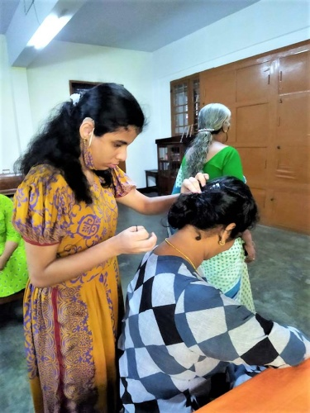

*Clay modelling Stitching Hair styling*

Short courses include tailoring, flower making, clay modelling, beauty treatments and dance and music. These courses have given the girls much joy and satisfaction. The goal is to bring the best out of these talented women and help them to find one or two activities that can help them earn a living and thus not to be a burden for their families (as is often the culture in India). They are also helped to find their identity through various personality development programmes and entertainments.

Also in September, another tailoring unit was set up within the Centre giving much needed work to women. Working in collaboration with a well-known production unit of nightdresses, this will help to solve an economic problem, as well as giving much needed support and friendship to the women. The project is under the guidance of Sr. Philo. Never ones to sit idle, the Sisters are proving their ability to continually adapt and diversify and be versatile in changing circumstances.

They are also providing educational support for a group of 6 girls who have the potential to excel in their studies, with a little helping hand. One student, Hridhya attained excellent results in her Plus 2 (equivalent to ‘A’ levels) exams: English A+, Hindi A+, Physics A, Chemistry A, Biology A+ and Maths A. Kerala Crafts was able to buy Hridhya a mobile phone during the pandemic, so that she could continue her studies whilst colleges were closed.

The staff at Vimalalayam continue to be a beacon of light and compassion in their community, and it was so good for them to be on the *receiving* end of an act of kindness. A crafter in Pembrokeshire, West Wales, has hand-made beautiful face masks and sent them from the UK, which were greatly appreciated.

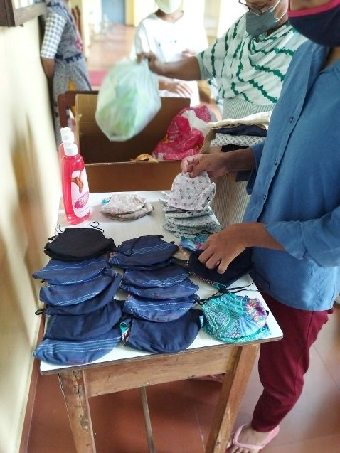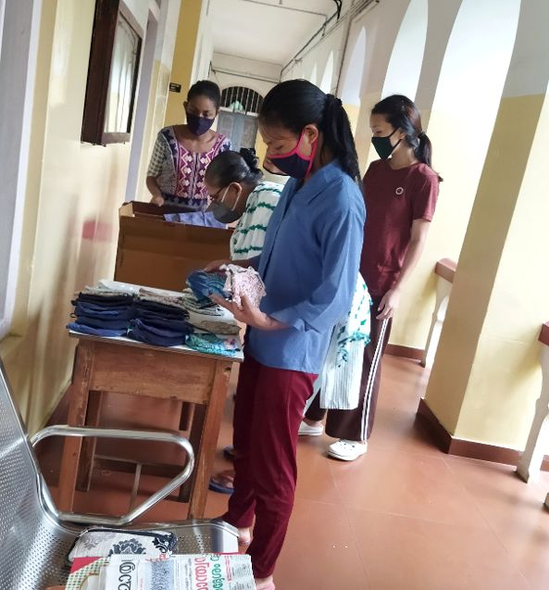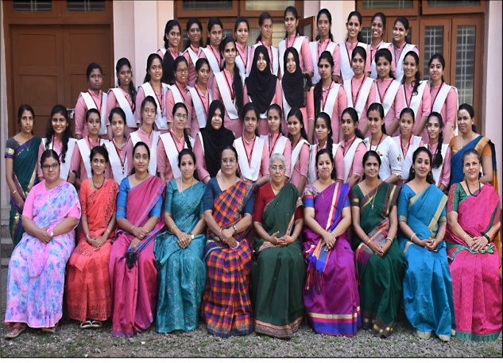

*Selecting masks at Vimalalayam Students & staff at Vimala College who received the UK masks*

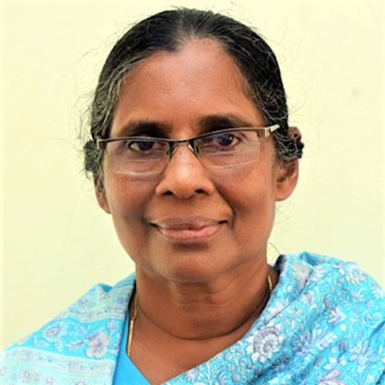 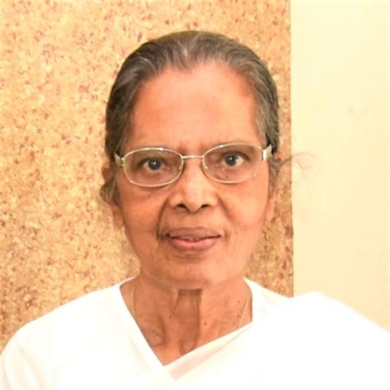 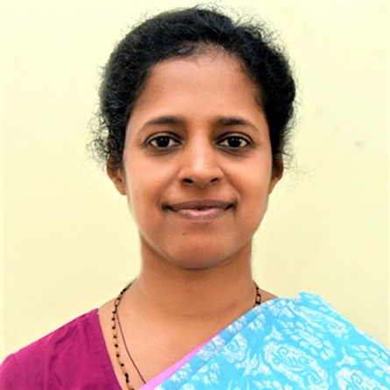

Sisters at Moolampilly:  *Sr.Mary Francis Sr. Aleyamma Sr. Nisha*

*2*

**Moolampilly & Kadamakudy**

Staff at the Vimala Centre have extended their outreach to these islands over many years by supporting the folk in finding a livelihood. These islands are part of a cluster of 14 islands, surrounded by the river Periyar. Moolampilly houses 676 families, most of whom are poor, some with disabilities and suffering ill health – made worse by the pandemic. Although 80% of the islanders were in employment in the private sector, most lost their jobs due to the pandemic and they have not been able to find much work since. Work on the island is mainly subsistence farming and fishing.

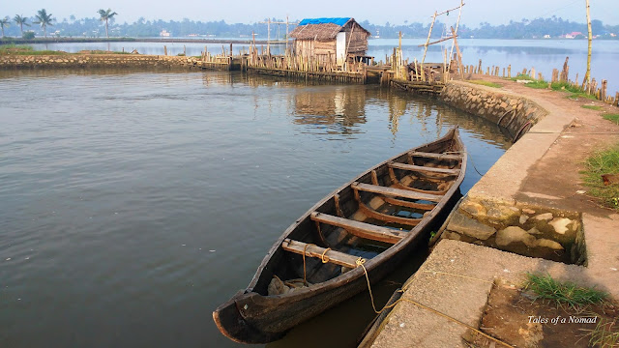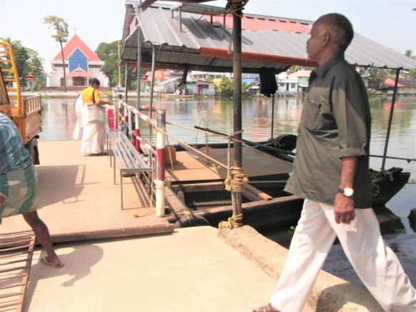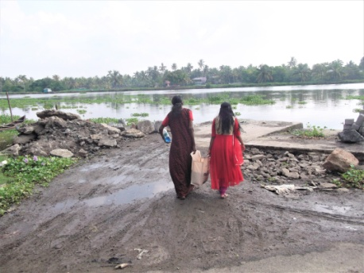

**Moolampilly** - is an isolated island 15km from Kochi. And although it looks an idyllic place, it is very vulnerable as the island lies only slightly above sea level and is subject to flooding. The terrible floods of 2018 were the worst in Kerala since 1924, and caused a great deal of damage which is still evident today.

With many people now forced to be at home with little or no work, the latest development will be the provision of a day care centre/pre-school, paid for in full by Kerala Crafts. As an annex to the building that was completed in February 2021, it will provide a focal point on the island and will benefit all ages, castes and religions who live there.

As an isolated area, the day care centre will give them a place where they will be able to meet each other, learn basic computer skills and tailoring skills too. Sewing machines have already been provided. As this new building can be added on to the existing building, it means that the same water connection and septic tank can be used, thus cutting costs.

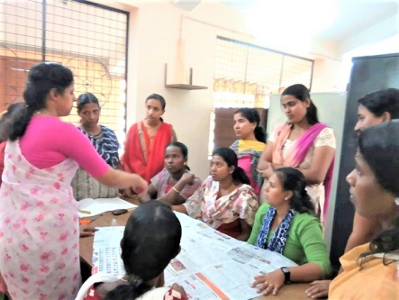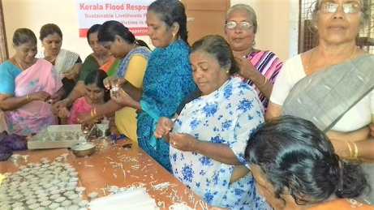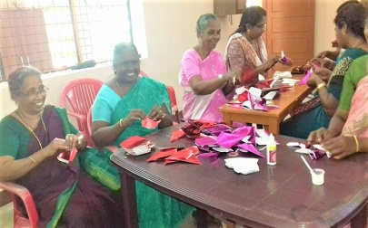

The pre-school facility, as well as benefitting the children, will mean that mothers will be able to seek employment thereby becoming financially independent, empowering them to be earning members of their families rather than passive ones – an important factor for single mums or women in abusive marriages. This is important because although there is a pre-school on the mainland, families are impoverished and so cannot afford the daily ferry fee.

The panchayat (village council) gave permission initially and in November ’21 the government granted permission to build and on 6th December the ground work started. The building will comprise a multi-purpose hall, two wash rooms and entry is via steps or a ramp. The space between the two buildings will house a fish tank, vertical garden and wall cupboard for storage. Work was a little delayed, but is now complete with the blessing taking place on 24th June 2022.

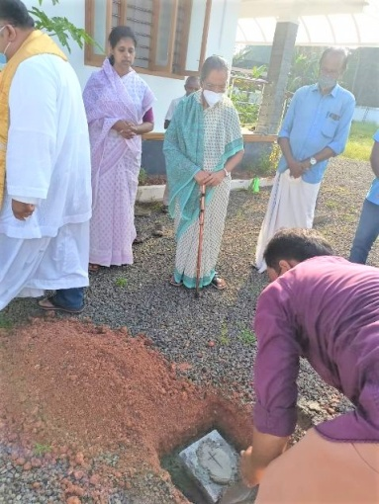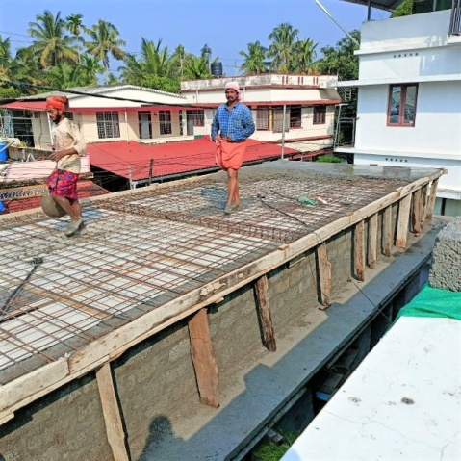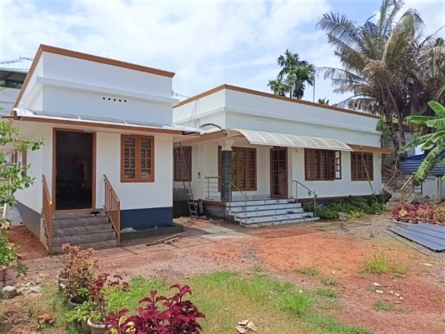

*Laying the sacred foundation stone Work in progress Neha Centre complete (named in memory of Shyni’s daughter)*

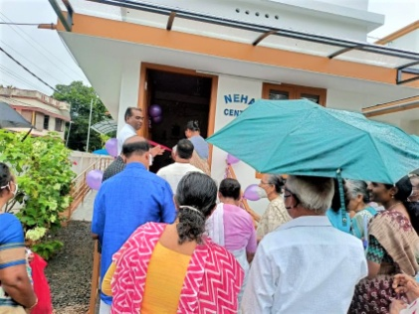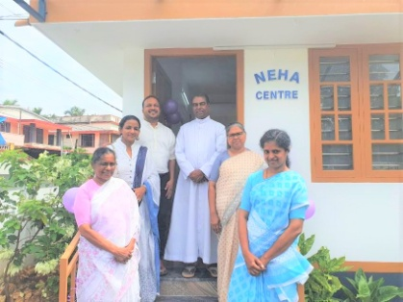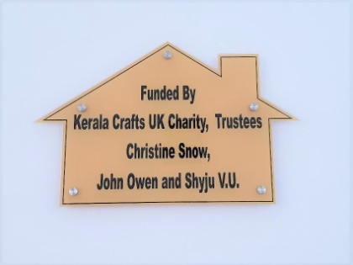

*Cutting the ribbon Neha’s uncle & aunt (top left)*

*3*

**Kadamakudy** – is a small island 8km from Kochi. The Sisters are continuing to lend support and care there. Kerala Crafts was able to help during the devastating floods, by helping to provide repairs to roofs, walls and ceilings and the provision of outside toilets. It would have been impossible for them to fund renovations and new installations by their own means.

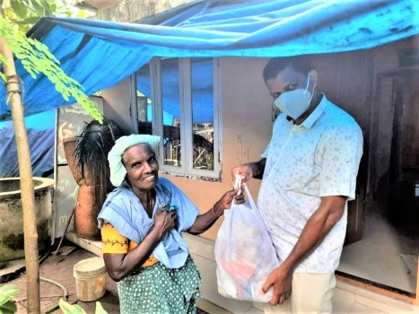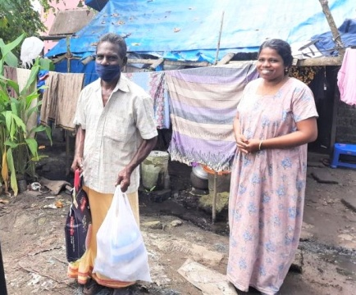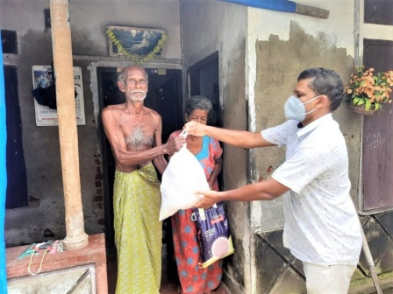

During the pandemic, the parish priest, Fr. Merton d’Silva, of St Joseph’s Church, worked tirelessly to help provide emergency supplies to the islanders, thanks to the generosity from The Sir Harold Hood Charitable Trust. A total of 110 families were provided with an essential kit containing food and medical supplies during lockdown.

At the end of last year, Fr. Merton, with extra help from Mother Theresa’s Sisters, worked tirelessly in Kadamakudy and nearby villages in the archdiocese of Verapoly, to bring relief from suffering.

As well as helping distribute food and supplies, Fr. Merton used his own small car as an ambulance to take folk to hospital during Covid, and contracted Covid himself. The island is a poor place, and no-one has a car because they cannot afford one and there is only a small causeway out of the island onto the mainland, apart from the ferry. When villagers are ill, there is no transport for them to be taken to a doctor or hospital, and they are unable to afford a taxi. There is a water taxi to Ernakulam (Kerala’s commercial hub), but many could not afford this; a boat with a doctor comes to the island on a Wednesday. That is the only outside help they receive.

The urgent need for an ambulance became clear during the struggles that Covid brought. Those sick and suffering islanders who needed urgent help with oxygen and treatment, had no vehicle to take them out of the island. As a result, many of the elderly residents died because of a lack of transport to the necessary facilities.

A second-hand ambulance was located which will be of benefit not just to Kadamakudy but also to Moolampilly and the other nearby islands. Even with Covid now subsiding, with an above average representation of elderly folk the need is always going to be there. The vehicle is the correct size to navigate the narrow causeway out of the island.

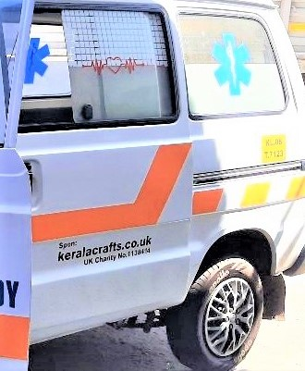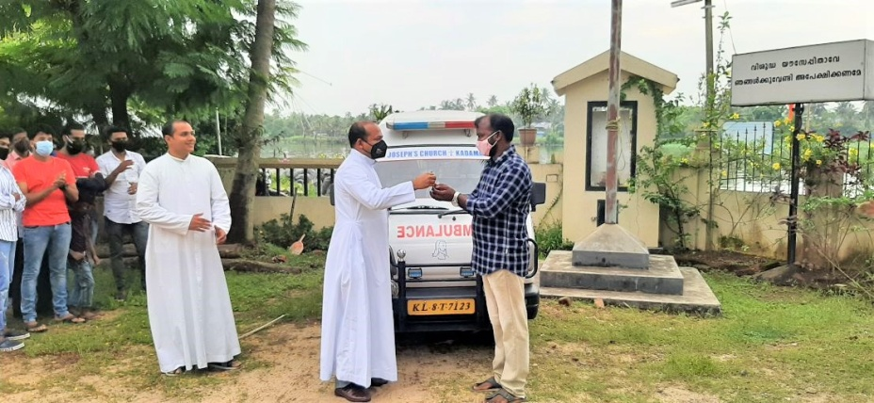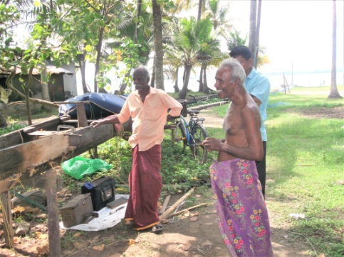

Half the cost of the ambulance was paid for by the church and islanders, but to save Fr. Merton taking on a loan for the rest, Kerala Crafts has paid the other half.

**Valsalya Bhavan** *Sr. Shirley* *Sr. Shini*

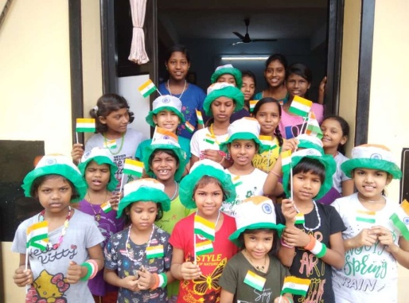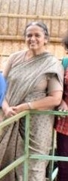 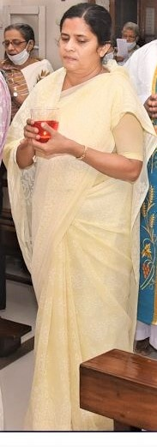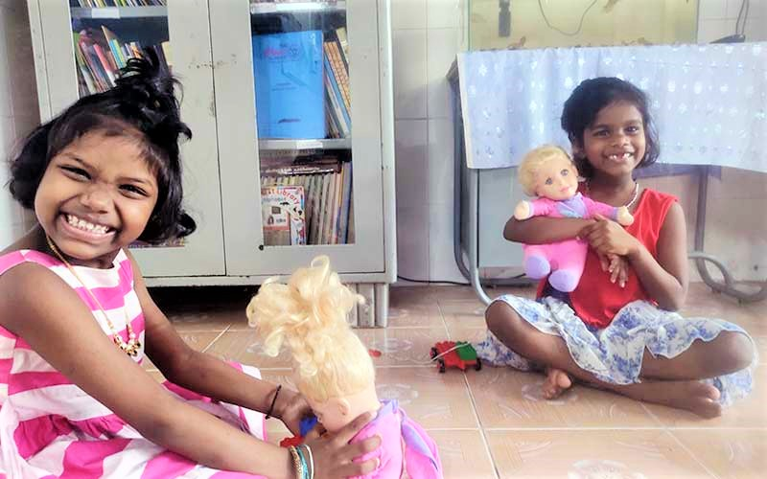

*Girls at Valsalya Bhavan Amathotti Playing with dolls*

*4*

Life has been a struggle for the girls and staff during the pandemic – younger girls at VB Ammathotti and the older girls at the annex. By September ‘21 all the girls and staff had Covid. Schools were closed but they continued to study online.

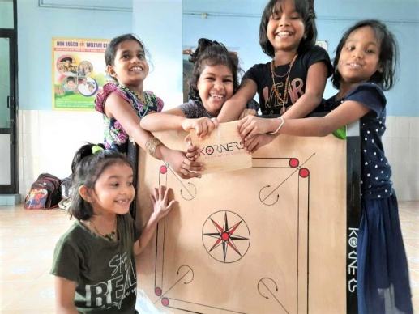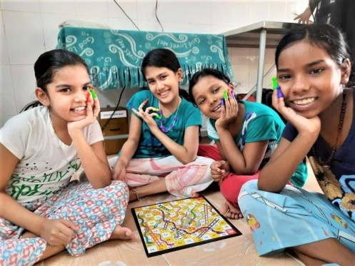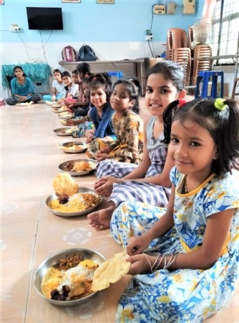

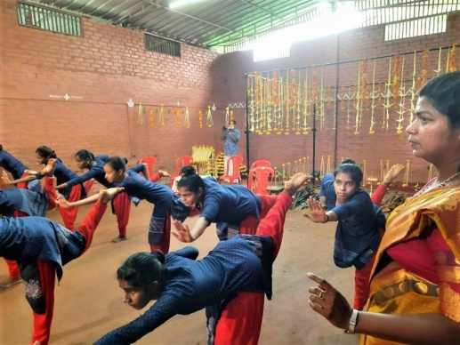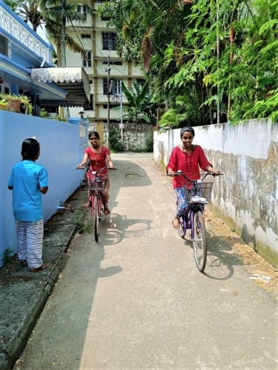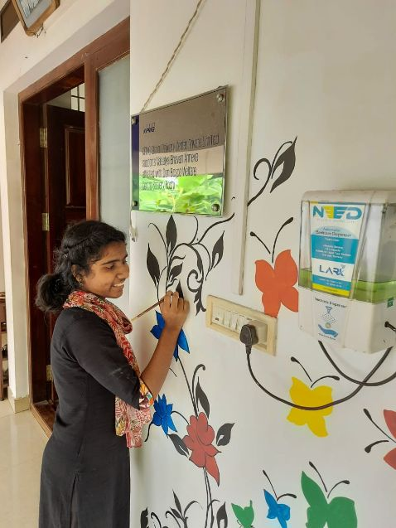

Thank you to all the sponsors of the girls – your monthly contribution is greatly appreciated. Apart from formal education, the girls have training in music, dance, drawing lessons and computer literacy, and your financial help enables them to develop their potential in all areas of life, and help them experience something of a ‘normal’ childhood.

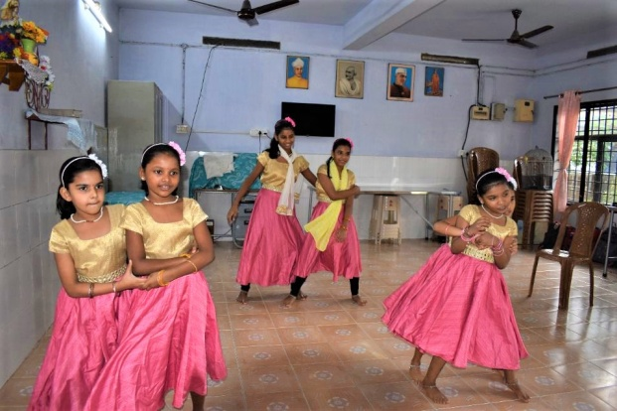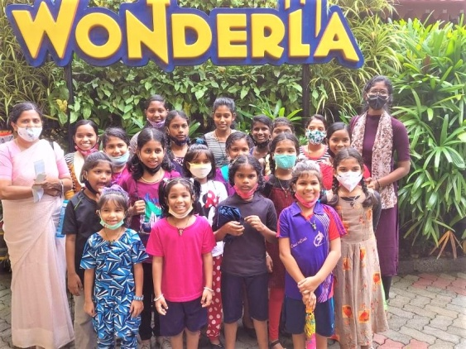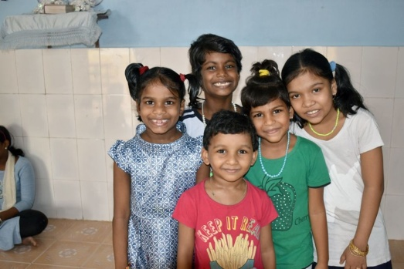

**‘You are the reason behind their smiles’**

If you are interested in being a sponsor please visit the website page <http://www.keralacrafts.co.uk/sponsorship.html>

You will receive a letter from the girl you sponsor at Christmas, and your support means so much to the girls **‘I thank you for all your help and loving concern because your help made us more happy and gave more meaning in our life’.**

***‘Aunty, I’m happy to say that I know it is by your help too that I get these opportunities. Actually I have no words to express my love and thanks to you. I know you also love me a lot. How can I repay this all? I am study hard and achieve my dream, and one day I’ll come to see you and will give you a big hug’.***

Fr. P.D. Thomas is the executive director of the girls’ orphanages as well as the boys, and recently he received an award for ‘the best non-profit in Kerala for care of children’ on behalf of the Don Bosco Welfare Centre Society.This is well deserved and congratulations go to him and all the staff and sisters who give such loving care to the children.

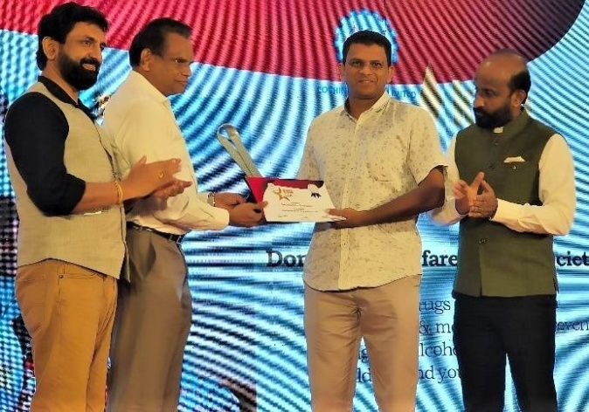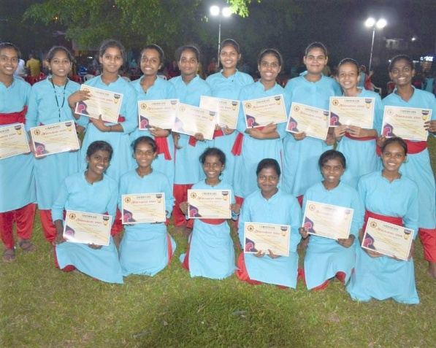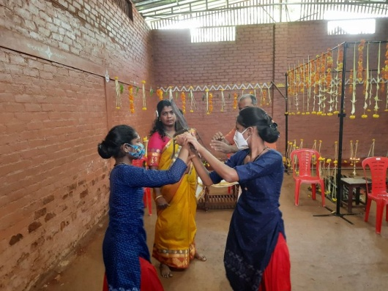

*Fr. Thomas (R) receiving award Receiving certificates at Dakshina Bharatha Kalari (self defence)*

*5*

On the 12th March ’22 it was International Women’s Day and the older girls took part in a performance organised by Dakshina Bharatha Kalari at Fort Kochi. Girls from the annex participated in the celebration and performed various steps and postures of ‘Kalaripayattu’. The girls have received training for the last two years. Thanks to all supporters whose contributions helped to provide training for the girls.

Recently, the Don Bosco Welfare Centre organised an ‘inter-orphanage spelling bee competition’. As part of the Rosetta Stone Learn English programme, the children from Don Bosco centres were learning English with the help of computers for the last 2 years. The words chosen for the competition were taken from the words they had learnt during the Learn English programme.

The competition was organised in two categories – Juniors and Seniors. The winners of the competition were awarded cash prizes of Rs5000, Rs3000 and Rs2000 respectively (£50, £30 & £20).

Our girls at Valsalya Bhavan (Ammathotti – juniors) won 1st prize Banaja

2nd prize Sajana

Our girls at Valsalya Bhavan (annex - seniors) won 1st prize Gowri

2nd prize Chinchu

Third prizes in both categories were won by boys from the Don Bosco Boys Home.

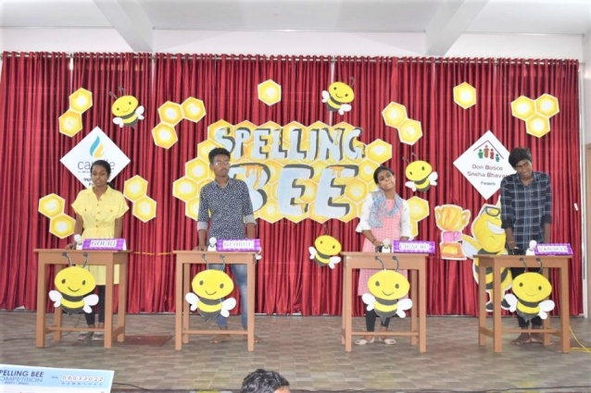 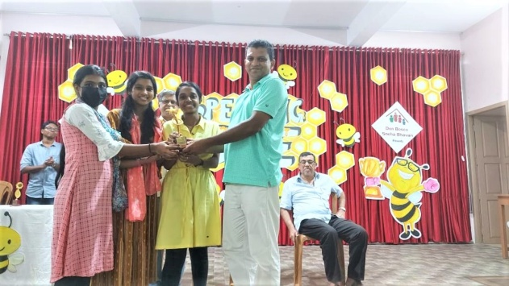

Congratulations to all the girls - they beat the boys!

**Story of Sonia:** From diffidence to finding confidence and esteem

Sonia was brought into Valsalya Bhavan in 2013 when she was a 9th grader. Having been brought up by a mentally ill mother, she felt different and isolated herself from other children at the home. Due to her lack of self esteem she secluded herself. At Valsalya Bhavan, in addition to academic learning, the children are offered various programmes such as dance, skill trainings, life skills etc. These programmes help the children to learn valuable life lessons. Sonia was initially reluctant to participate but eventually she came out of her shell. She started making friends and she realised that she was not very different from the other children. She saw that there were children who had gone through worse sufferings than her, yet they were happy. She learnt a valuable lesson that there is no point in being sad and that it was

time to grow up. As she started enjoying these programmes, she saw that she was getting better at them. This developed confidence and more importantly a sense of self worth.

Before she was brought in to the home, she used to accompany her sick mother to hospital. Here she noticed how the nurses would help her mother with everything. Sonia was now able to combine her past experience with her new found sense of purpose. Today Sonia is studying for a post B.Sc. in nursing at Mangalore, Karnataka, having gained 85% in her degree in general nursing at Ernakulam Medical Trust Hospital. She’ll also get two years experience by the time she finishes. Sonia was at Valslaya Bhavan for many years, and has done so well to get where she has.

To really help with her studies, we are again grateful to C.N.D. Ltd for providing her with a laptop.

Sonia so appreciates her long-standing sponsorship from a lovely lady in The Netherlands who has enabled her studies; she wants to help people and achieve great things in life. Most importantly she wants to support and help her mother.

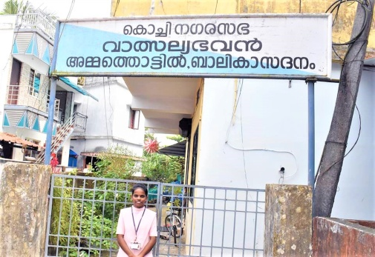 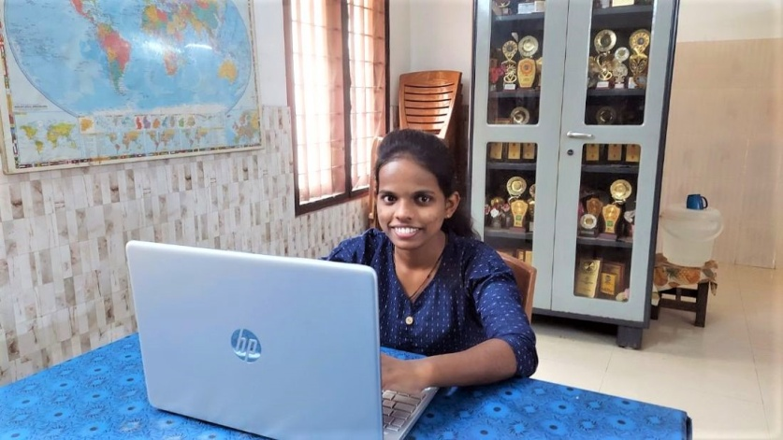

*Sonia as a student nurse outside the orphanage Sonia with her new laptop given by CND Ltd*

*6*

**Sneha Bhavan**

Sneha Bhavan is a leading non-governmental, non-profit organisation working for underprivileged and at-risk boys. The home in Palluruthy, Kochi was established in 1977, and comes under the same Don Bosco umbrella as the girls’ homes.

Along with regular education, the boys are given skill training, life skills education and training in different sports and games, music and art in order to provide aptitude based multiple options for developing a career. Some of the boys have been state level champions in judo, boxing, sports events etc.

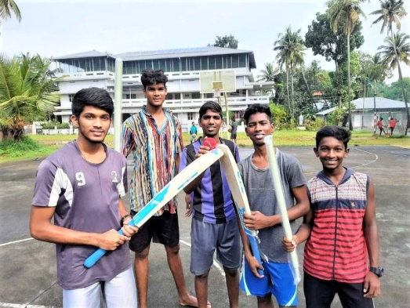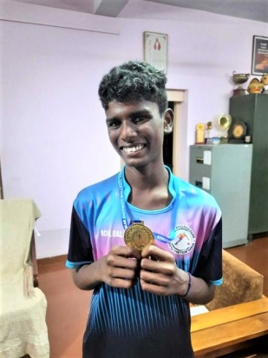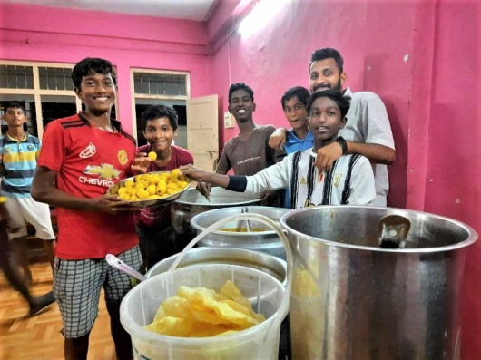

Kerala Crafts has recently been able to support this work, albeit in a small way, by purchasing handicrafts made by some of the boys, such as macramé plant holders, keyrings and novelty decorations. The money is deposited into their own bank accounts for their future studies and rehabilitation.

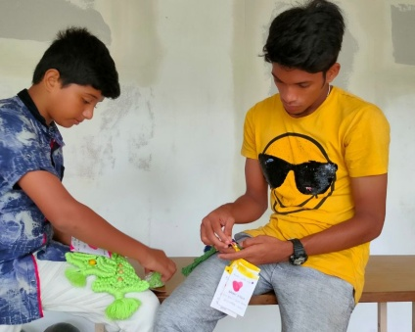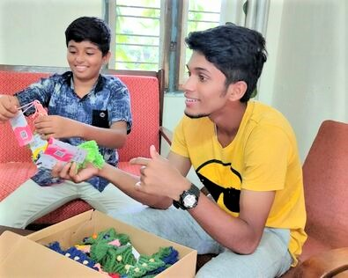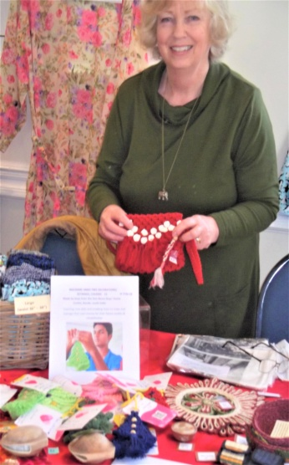

*Packing up crafts to send to the UK Selling them at a Xmas sale in Bath Attaching hand-made labels on each one*

Emmanuel is one of the past pupils needing help to strengthen his home before the monsoon season. Emmanuel found himself at Sneha Bhavan because both his parents died of TB when he was 7. After leaving Sneha Bhavan after many years, he worked as an auto rickshaw driver, and went on to get married and have 2 sons. They live in a simple house on the sea shore, and had issue with heavy rainfall and strong winds, so much so, that their house is on the verge of collapse.

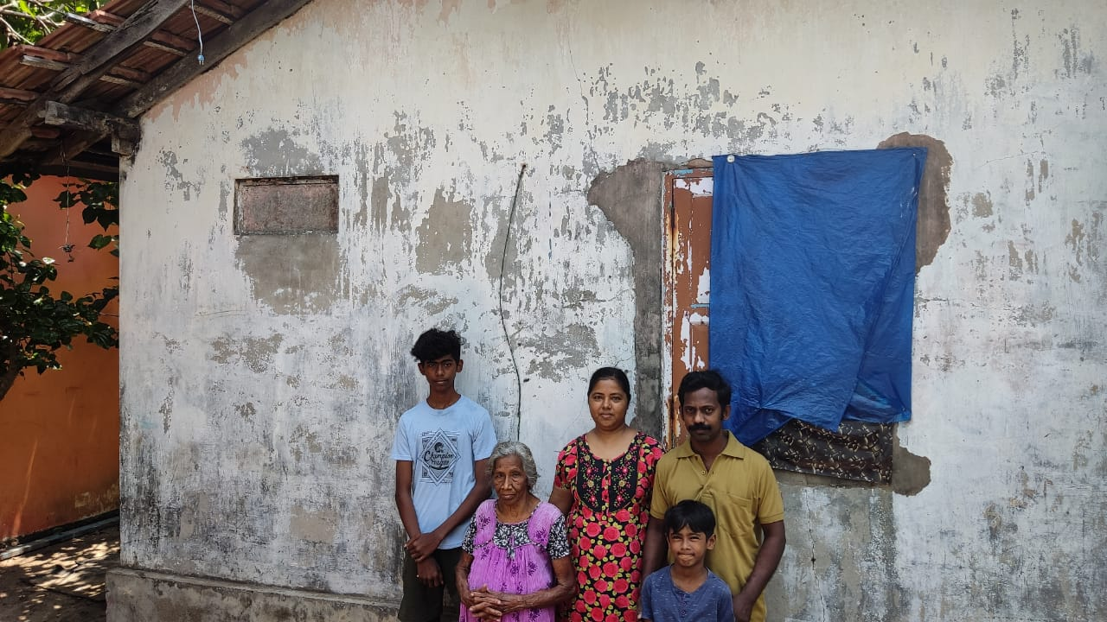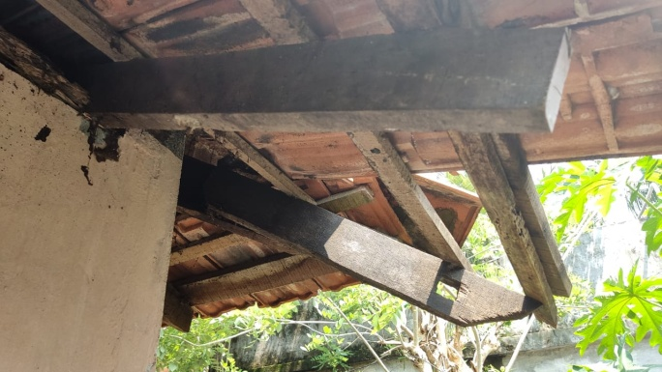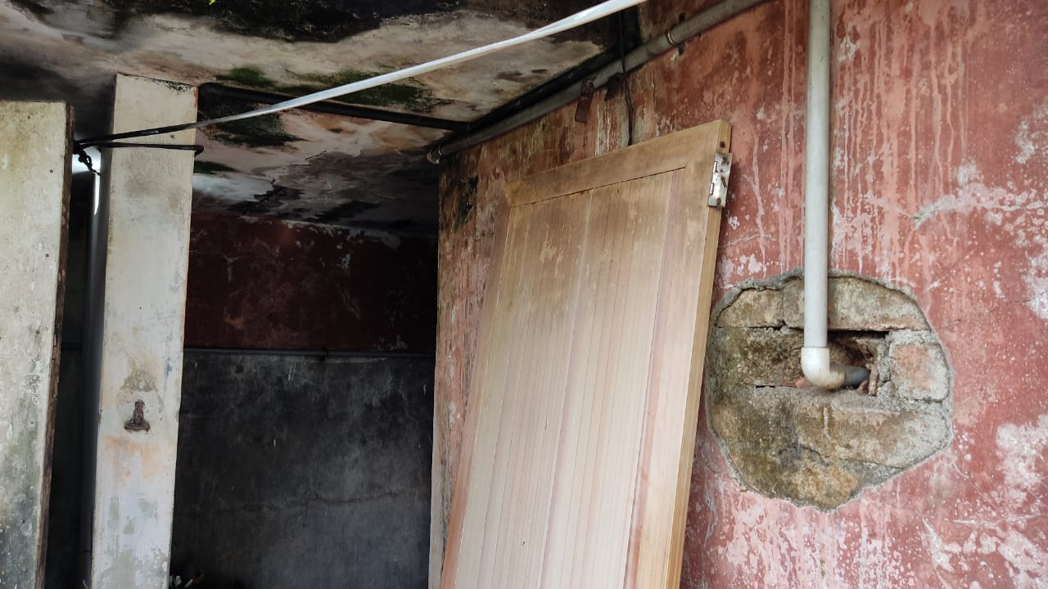

*The family at home Bad state of their home*

Supporting his wife Kochuthresia, 2 sons and his mother, has put a lot of pressure on Emmanuel, and at the beginning of 2021 his wife became unwell with severe headaches and partial vision loss. This was diagnosed as autoimmune hypophysitis which is an inflammatory condition of the pituitary gland.

The family are under a great deal of financial pressure from both Kochuthresia’s medical bills and the precarious state of the house, which must be rectified before the monsoon breaks.

Kerala Crafts has sent a donation towards the work, to add to a donation from the Don Bosco Snehabhavan Alumni.

7

**She’s**

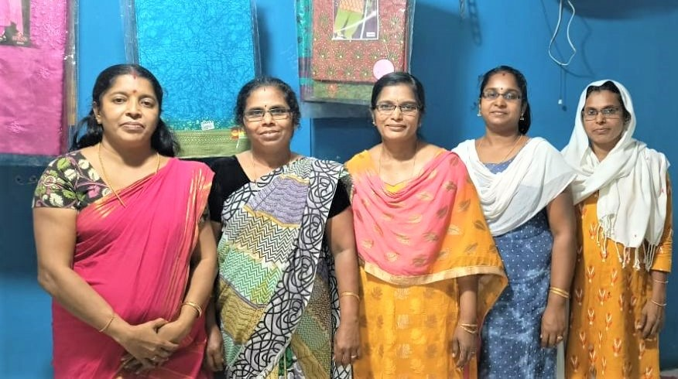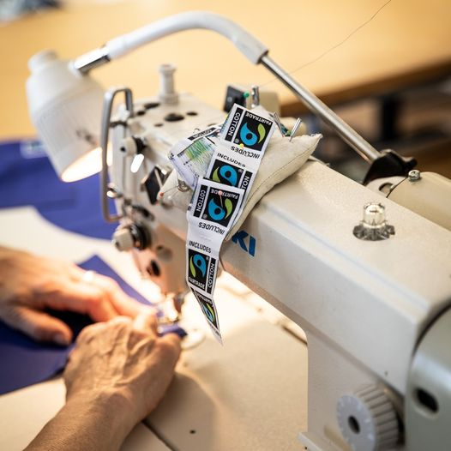

Shyni Seetha Suma Sajitha Naseema

It has been another challenging and difficult year for the ladies at the workshop in Ponnani. In August 2021, the shop was still closed. Ponnani remained top of the list in Kerala for having the most cases of Covid. Shyni (the shop manager – far left) was told that she could open the shop with the shutter half down, and no customers were permitted inside the shop. It could only be open for stitching purposes, with just 3 workers in at one time.

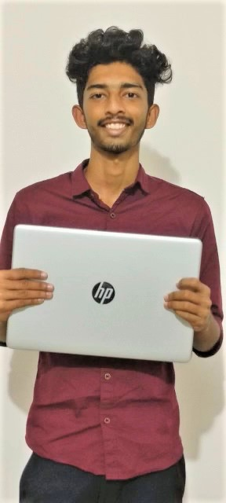 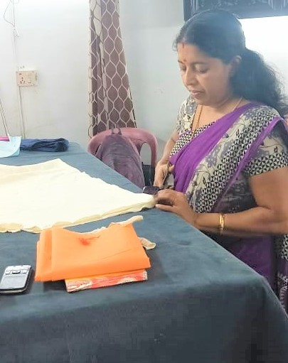 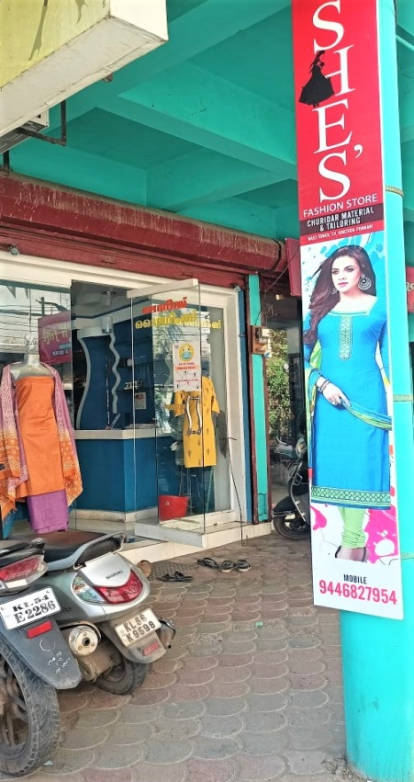

*Kannan with his new laptop Mum, Shyni at the shop Outside ‘She’s’, Ponnani*

By the beginning of September, the shop was fully open again with lockdown only on Sundays. Another tragedy befell Jalaja in the same month. Her husband took his own life (her son did the same in the previous year). Jalaja has struggled to return to work, and has been working from home, but hopes to return to the shop on the first anniversary of her husband’s passing. Our hearts go out to this lovely lady at this difficult time.

Another worker, Vijaya left to have a baby, and is now the mum to a son. Her place has been filled by Suma.

Shyni’s son, Kannan, commenced a three year B.Sc Medical Imaging Technology degree at the SRM Medical College in Chennai in November. He was only there for a short time before returning home to study online because of the omicron variant. By March 2022, he was back in Chennai.

Kerala Crafts is providing funds for his college fees and lodgings. C.N.D Ltd are also supporting Kannan’s studies by providing him with a laptop.

This is an important step for Kannan – his father is seriously ill and unable to work, so Shyni would be unable to fund his move to university. His further education with prospects of a good job to follow, will help the whole family in the future.

*8*

A family in Chalakkudy, 23 miles north of Kochi, known to Shyni’s brother (a Kerala Crafts trustee) and wife, were really struggling during the pandemic. The father had lost his job during Covid and his children were unable to access online classes. With help from Bel Mooney, a laptop was purchased to provide the two sisters Angel Joy and Agnes Joy with a helping hand for their studies. We are grateful to Bel, who did this through our Meaningful Gifts page.

<http://www.keralacrafts.co.uk/meaningful-gifts.html>

## Laptop donation (2).jpgtablet pix again (2).jpg

**Noor the Tailor**

Noor has continued to make our boxer shorts, but again with slow sales, we have been unable to order new stock. Niyas (our man on the ground) continues to source new products and recently we have added essential oils to our range. We are able to support him during this difficult time for his whole family as he endeavours to find new work. C.N.D. Ltd have been able to help his daughter and son by providing a laptop, which has proved invaluable in their studies.

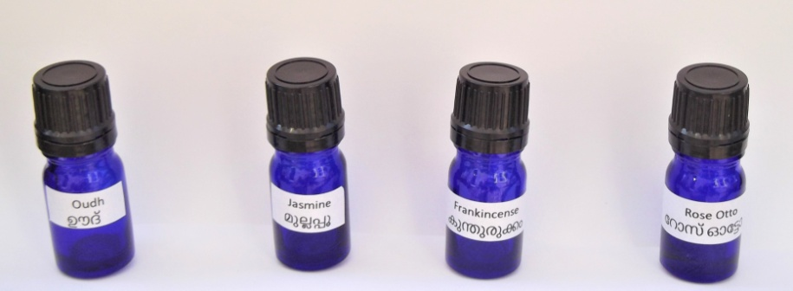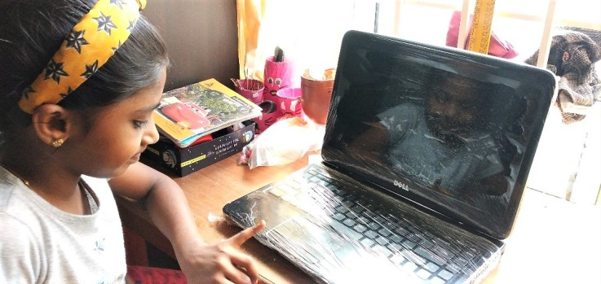 

*Oudh, Jasmine, Frankincense & Rose Otto- all mood enhancing Mysha with her laptop*

The knock-on effect of the pandemic, plus the cost of living increasing in the UK recently, sales at Kerala Crafts have hit an all time low. We are extremely grateful that we have received funding from charitable trusts, namely The Souter Trust, The Ashworth Trust, and a legacy from the late Dame Diana Rigg. We are grateful also to C.N.D. Ltd for their thoughtful and practical help in supplying 3 laptops to needy students, as well as a large screen TV for the new centre at Moolampilly, and also providing stationery for the children at the orphanage, including the poor and needy children in the neighbourhood. After one and a half years of not attending school, this was much needed.

The help with funding we have received has enabled us to sustain our level of giving to the projects close to our hearts, especially where it has been needed most. This help to provide emergency relief to many during the pandemic is very much appreciated - plus the generous giving of our regular supporters has enabled our work to carry on. Another ‘man on the ground’, Kumar, worked tirelessly with **Go Fund Me** which was set up to help locals in need in the areas that are known to Kerala Crafts. We were able to pass on funds granted to us, to **Go Fund Me** to provide basic food and medical supplies. The Dhobi Kana (laundry), originally established in 1720 when workers washed the uniforms of the Dutch army, was badly affected by Covid. Forty five workers there were helped. Many families in Fort Cochin and the nearby rural village of Kumbalangi, 15 km from Kochi where a high number of people were infected by Covid, and hence in dire need of support were also given aid through this scheme.

It was fitting that the last day of the campaign (having reached its goal of £5,000), was Happy World Kindness Day, as it was kindness that made it all possible.

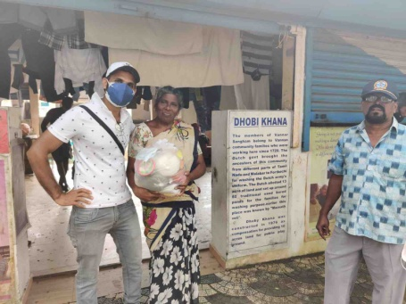 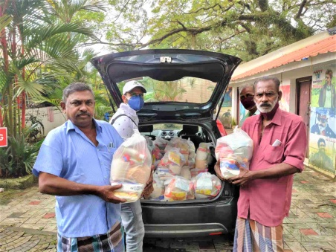 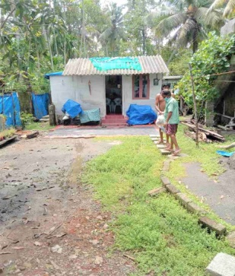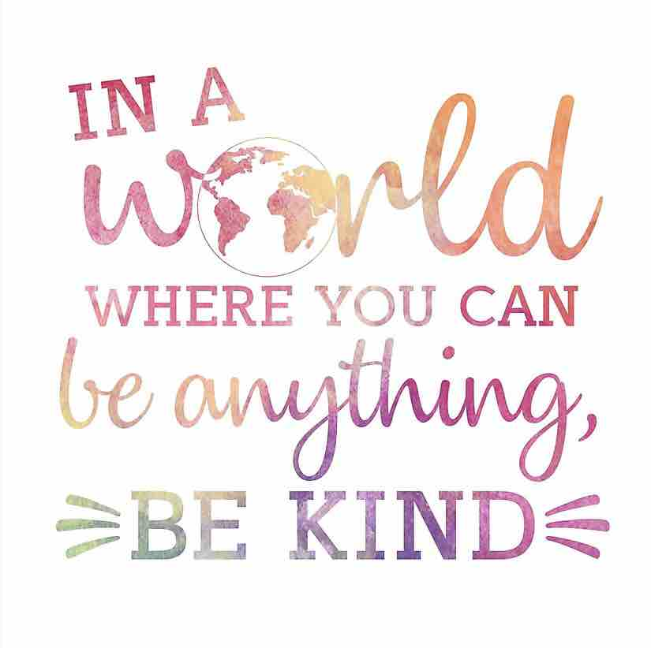 *Kumar (L) distributing food packs at Dhobi Kana Packing up supplies to deliver to ...... .... rural Kumbalangi*

*9*

Here are some of the words of thanks received from a few of the many who received food parcels:

‘Dear friends, I find no adequate words to express my sincere gratitude to the invisible good hearted people behind the gift pack just delivered to me. Blessed be the efforts with good health, long life, prosperity and good luck’.

‘A very special thanks for the good hearted people to donate the kit. Did a wonderful act and remembering our community in this pandemic, thanking them again’.

‘Kit received. Thanks to all my brothers and friends behind this. I have no words to show my gratitude. God bless all of my brothers, thanks to who gave this mercy on us’.

Most of our associations are relatively small, but they are personal contacts all known to us over many years. Kerala Crafts aims to focus on the sustainability of its existing projects to safeguard their futures so that they continue to have the ability to provide care long term. Our sincere thanks to all those who have given.

If you are able to help us to support these projects please see our website, going to our ‘About Us’ page (How can I help), or Meaningful Gifts page or News Page, or please just get in touch.

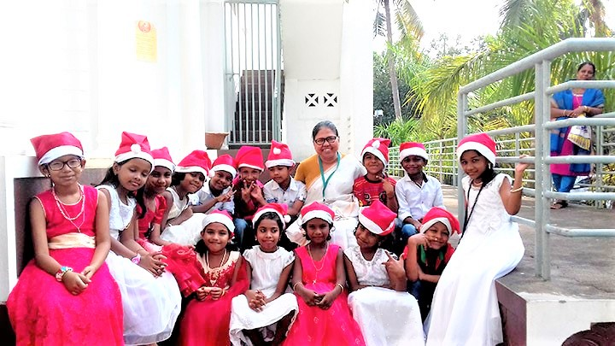

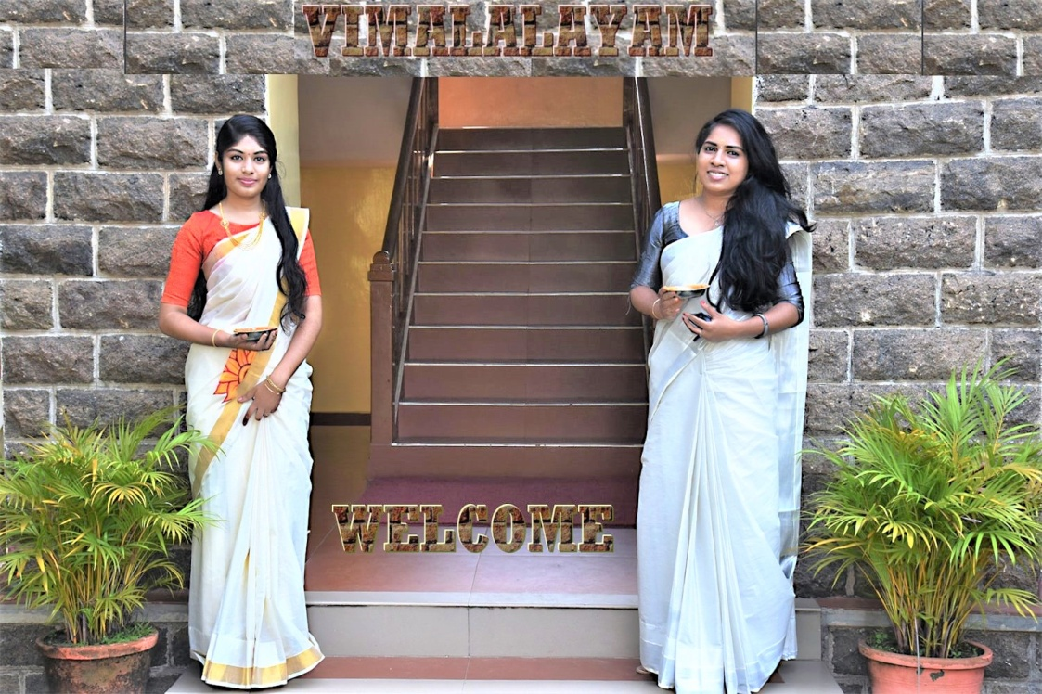

[www.keralacrafts.co.uk](http://www.keralacrafts.co.uk)

Tel: 01225 319642

*10*